**Name: Ahmed Yousri Ali Mohamed Hassan**

**Course Name: Field Training 1**

**Instructors: Eng. Mohamed Hatem,**

**Eng. Mohamed Wael,**

**Eng. Menna Ashraf**

**ID: 2103108**

**Program: Intelligent Systems**

**Submission Date: 31/8/2023**

**Training Name: Internet of Things: Theory and Applications**

**Training Place:** **Faculty of Computers and Data Science,**

**Alexandria University**

**Training Duration:**

**From 8th of July, 2023 to 19th of August, 2023 ,**

**42 Days**

**TRAINING**

**REPORT**

**Field Training 1: IoT (Internal)**

**TABLE OF CONTENTS**

**1. INTRODUCTION**

[PAGE NUMBER:3]

**2. Training topics and instructors**

[Page NUMBER: 4]

**3. Training Participants**

[Page NUMBER: 5]

**4. Methodology of Training**

[Page NUMBER: 6]

**5. Training details**

[Page NUMBER: 7]

5.1 Week 1&2

[Page NUMBER: 7]

5.2 Week 2&3

[Page NUMBER: 9]

5.3 Week 4&5

[Page NUMBER: 15]

5.4 Week 6

[Page NUMBER: 20]

**6. Training project**

[Page NUMBER: 25]

**7. Challenges and Solutions**

[Page NUMBER: 38]

**8. Learning Outcomes from IoT Training**

[Page NUMBER: 43]

**1. Introduction**

The field training program is designed to provide a comprehensive understanding of both theoretical concept and practical skills of IoT systems. Its structure revolves around five integral layers, each of which contributes to the intricate architecture of IoT. Subsequent to the foundational sensing layer housing microcontroller-embedded sensors, we delve into the device layer utilizing the ESP32 Dev Kit V1 microcontroller. The journey then advances to the communication layer, deftly employing built-in Wi-Fi for seamless data transmission. This layer's success leads us to the cloud layer, where connections to platforms like Firebase are established, solidifying the integration of data streams. Finally, the application layer comes to the forefront, offering engaging web and mobile graphical user interfaces powered by Flutter.

During the training, our comprehension and practical skills were meticulously evaluated, both individually and through collaborative efforts. This multifaceted skill development culminates in a capstone project that effectively mirrors real-world applications.

Throughout the program, there is a notable emphasis on fostering teamwork dynamics, refining the art of effective communication, and mastering the art of meticulous documentation. These aspects are cultivated through interactive discussions with both peers and trainers, providing a holistic approach to skill enhancement.

**2. Training topics and instructors**

**The core subjects covered during the training:**

1. Basic and Advanced Programming, coupled with Problem-Solving

using C++.

2. Embedded and IoT Systems through hands-on experience with

ESP32 by Espressif Systems.

3. Cloud Platform as a Service, utilizing Firebase by Google.

4. Skill development in crafting User Interfaces and utilizing the Software

Development Kit using Google's Flutter framework.

**Training Instructors:**

|  |  |  |
| --- | --- | --- |
| Instructor | Topics | Training Duration |
| Eng. Mohamed Hatem | * Basic & Advanced Programming and   Problem Solving using  C++.   * Embedded & IoT Systems using ESP32 by Espressif Systems. | 30 hours:   * 12 Hours Lectures * 6 Hours On-site Practice * 12 Hours Assignments &Projects |
| Eng. Mohamed Wael | * Cloud Platform as a Service using Firebase by Google. | 15 Hours:   * 7 Hours Lectures * 3 Hours On-Site Practice * 5 Hours Assignment & Projects |
| Eng. Menna Ashraf | * User Interface & Software Development Kit using Flutter by Google. | 15 Hours:   * 7 Hours Lectures * 3 Hours On-Site Practice * 5 Hours Assignment & Projects |
| Total of hours | 60 hours | |

**3. Training Participants**

The training had active participation from a diverse group of undergraduate students hailing from the esteemed Faculty of Computers and Data Science.

The represented programs which enrolled were:

* Cybersecurity
* Intelligent Systems,
* Computing and Data Science
* Business Analytics
* Healthcare Analytics.

A total of 83 students were engaged in this training.

The training method emphasized the value of teamwork, and I had the opportunity to collaborate with a group of peers who became my fellow team members:

1) Name: Ahmed Dawood Mohammed

ID: 20221454408

2) Name: Ahmed Ehab El-Sayed

ID: 20221445838

3) Name: Fares Hazem Mohamed

ID: 20221443356

4) Name: Omar Gamal Abdelaziz

ID: 20221446135

As a cohesive team, we delved into the training's content, pooling our individual strengths and insights. We could collectively tackle tasks, share ideas, and learn from one another.

**4. Methodology of Training**

1) Interactive Sessions:

The training sessions unfolded as a series of engaging theoretical lectures, each meticulously crafted to establish a robust foundational understanding. These sessions, expertly led by subject matter authorities who possessed both theoretical expertise and practical experience, delved deeply into each concept.

2) Hands-on Learning:

Hands-on learning was at the heart of the training's pedagogical approach. Attendees were presented with a diverse range of practical challenges and mini projects, providing a platform to tangibly apply the theoretical knowledge garnered from the lectures.

3) Collaborative Approach:

The training seamlessly integrated collaborative learning. Each concept, task, or project was extensively discussed with subject matter experts, ensuring a comprehensive understanding among all participants.

4) Ongoing Assessment:

Team-based assignments were meticulously designed based on the theoretical concepts introduced during lectures and practical tasks. These assignments were presented during the training sessions.

5) Capstone Project:

Teams executed real-world IoT projects. Each team embarked on the creation of a real-world project within the realm of Internet of Things, whether it be Smart Homes, Smart Cities, Smart Fire Fighting Robots, Smart Hotel, or Smart Line Followers.

6) Time Management:

This training included a detailed exploration of tasks' time management and effective utilization of time. We gained insights into essential practices such as planning, goal setting, analysis of time allocation, ongoing monitoring, efficient organization, and strategic scheduling.

**5. Training details**

**5.1 Week 1&2:**

During the first 2 weeks, we covered the following topics:

1. Training Brief:

We engaged in discussions about the training's overall structure, including its

lifecycle, plan, platform, evaluation methods, expected duration, to-do list, and

team dynamics.

2. IoT in a Nutshell:

We delved into the evolution, definition, and distinguishing characteristics of the

Internet of Things. Additionally, we explored IoT architectures and the

fundamental building blocks that constitute this dynamic field.

3. Basics of Computer Science and Engineering:

This segment introduced key computer science and engineering concepts. We

explored topics such as transistors, their types, abstraction, computer components,

machine and assembly languages, program design, algorithms, programming

language generations, pseudo code and flow charts, syntax, compiler and

interpreter roles, object and source codes, and the Software Development Life

Cycle (SDLC).

4. Basics of C++ Programming:

We were introduced to the fundamentals of C++ programming, including its definition, integrated development environment (IDE), basic syntax, GNU GCC compiler usage, and our first C++ program.

5. Variables and Operators:

This topic covered variable initialization, declaration, and assignment, as well as constants, identifiers, data types, namespaces, directives, text input and output, escape sequences, comments, numeric and character data types, boolean data types, string classes, unsigned data types, type casting, and various operators.

6. Conditions:

The concept of flow control was explored, focusing on the “if” statement, “shortform if”, “nested if”, “if else if”, and “switch” statements.

7. Loops

We investigated the concept of repeating statements through “do while loops”,”'for

Loops”, “while loops”, and “nested loops”.

8. Functions:

This segment covered the divide and conquered technique, function syntax, function

types (pre-defined and user-defined), function declaration, void and value-returning

functions, parameters with default values, boolean functions, variable scope, call by

value, call by reference, function hierarchy, overloading functions, pre- and post

conditions, and the relationship between functions and loops.

9. Arrays:

We explored array definition, initialization, and declaration, as well as arrays within

loops, arrays in functions, array parameters with call by reference, and 2D arrays.

10. Pointers:

Pointer concepts were discussed, including definition, types, initialization,

declaration, variable and dereference, pointer operations, dynamic variables

,and the distinction between automatic and static variables.

11. Strings:

We covered two main types of defining strings: C-strings (arrays of characters) and

the standard string class. We examined their initialization, declaration,

manipulation, loops, assignment, function interactions, equality, concatenation,

input/output usage.

12. Object-Oriented Programming (OOP) using C++:

We delved into essential OOP concepts, including structs, classes, objects, and inheritance.

13. We practice all these topics in both lectures and assignments:

1. I've developed a C++ program for credit card balance calculations, part of my IoT project, demonstrating coding skills and problem-solving.

The program operates in a loop, allowing multiple calculations without restarting. Users input their balance, and the program handles the rest.

After inputting the balance, the program determines the interest rate. Balances above 1000 have a two-tiered rate: 0.015 up to 1000, 0.01 beyond. Below 1000, it's a flat 0.015.

Next, the program calculates the total owed by adding the balance and interest. It then calculates the minimum payment. If owed > 10, it's 10% (unless > 10), else flat 10.

After calculations, the program displays interest, total owed, and minimum payment. These values accurately represent the financial situation based on input.

You can exit (0) or continue with different inputs (non-0) in the loop, offering flexibility for multiple calculations.

2. I've developed another C++ program showcasing my coding skills.

This program performs number analysis, including perfect square detection, digit

reversal, and digit sum calculation.

Users interact through operation codes (1 for perfect square, 2 for digit reversal, 3 for

digit sum, and 0 to exit), enabling seamless calculations within a loop.

Users input numbers for analysis, triggering specialized functions.

The isPerfectSquare function checks for perfect squares, while reverseDigit and

calcsum manage digit manipulation and summation.

Robust input validation ensures user-friendly interaction.

**5.2 Week 2&3:**

During week 2&3, we covered the following topics:

1) Basic Electrical and Electronics Components:

We delved into both active and passive components, AC and DC sources, voltage, current, power sources, resistance reading, resistors' parallel and series connections, power rating, Ohm's law, utilizing breadboards and jumper wires, voltage and current dividers, Kirchhoff's laws, AVO meter usage, and an array of components including semiconductor diodes, LDRs, potentiometers, push buttons, LEDs, voltage regulators, transformers, capacitors, inductors, MOSFETs, BJT transistors, DC motors, H Bridge, opto-couplers, relays, and operational amplifiers. Concepts progressed to encompass analog and digital signals, analog-to-digital conversion, digital-to-analog conversion, and pulse-width modulation.

2) Introduction to Embedded Systems:

We discussed the concept of Embedded Systems, covering its definition, embedded software, distinguishing features, and specialties. We explored the lifecycle, history, characteristics, real-time system types, classification, microcontroller characteristics, pull-up and pull-down resistors, system-on-chip, layered architectures, microcontroller selection, programming, software design, and development processes. The discussion extended to real-time operating systems (RTOS), communication technologies, protocols, and interfaces within embedded systems.

3) ESP32 Based IoT and Embedded Systems:

We examined Arduino-based embedded systems, delving into Arduino's significance and types of boards. Focus shifted to ESP32-based IoT systems, their advantages, technical specifications, architecture, basic and advanced programming syntax on the Arduino IDE, and serial communication.

4) Sensors and Actuators:

Topics spanned transducers, sensor types, sensing processes, characteristics, errors, precision vs. accuracy, IoT and embedded systems sensors, proximity sensors, infrared-based optical proximity sensors, and the utilization of MH infrared proximity sensors.

Sensors that we used:

* Flame sensor
* Ultrasonic sensor
* IR Sensor
* PIR Sensor
* Smoke Sensor
* Temperature Sensor
* Force Sensor

Actuators were explored, covering actuation processes, characteristics, types, electrical actuators, motors, servo motors, and DC motors.

5) Output Modules:

Output modules and display types were discussed, including LCD and OLED interfacing with ESP32, configuration, communication, technical specifications, and programming.

6) Input Modules:

We explored input modules, GPS module, keypad and switch modules, and self-adhesive membrane keypad modules. Concepts encompassed characteristics, applications, working principles, connections, technical specifications, controls, and programming implementation.

7) We practiced all these topics in both lectures and assignments, and here are some photos of the sensors, actuators, input, and output modules we used in the assignments:

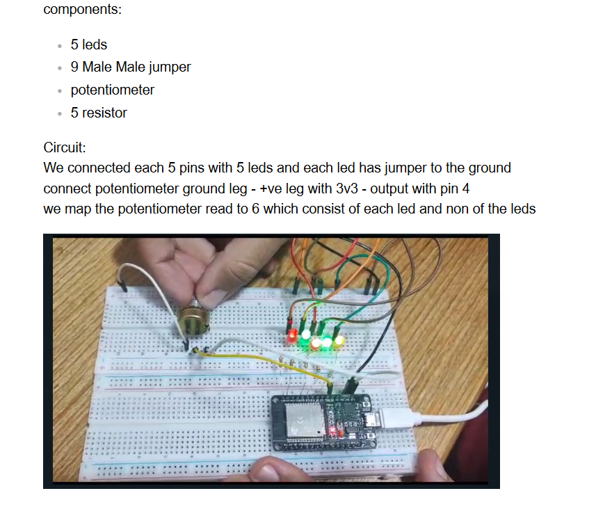1. Potentiometer convert leds to be on:

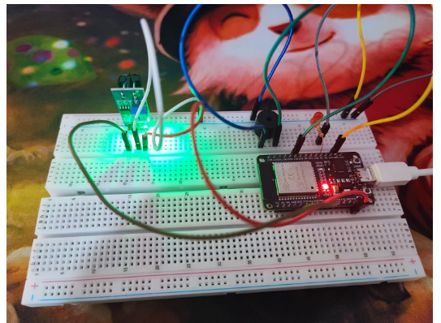2. Reading distance using IR sensor:

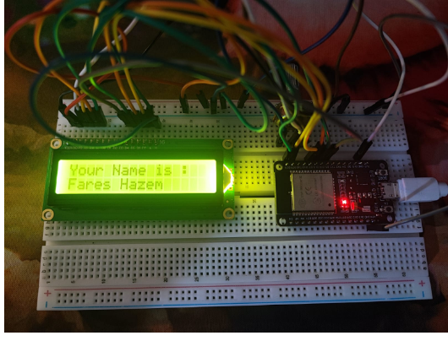3. Display name on LCD which wrote it in serial monitor:

4. Reading distance using Ultrasonic sensor:

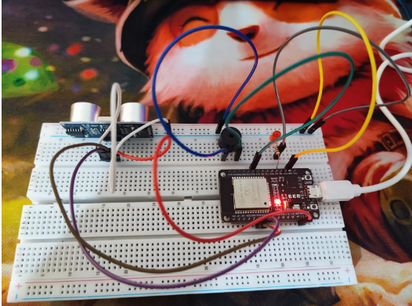

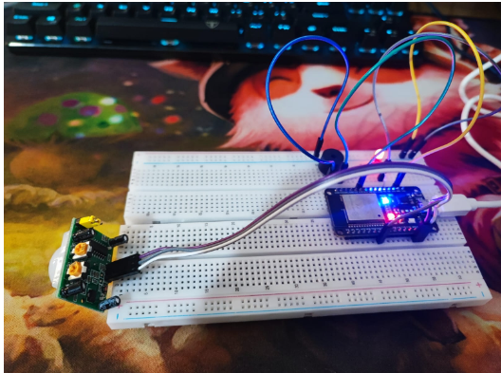5. Reading motion using PIR:

6. Detecting Flame using Flame sensor:

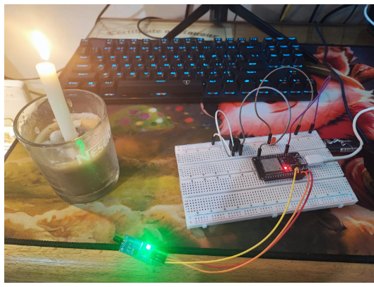

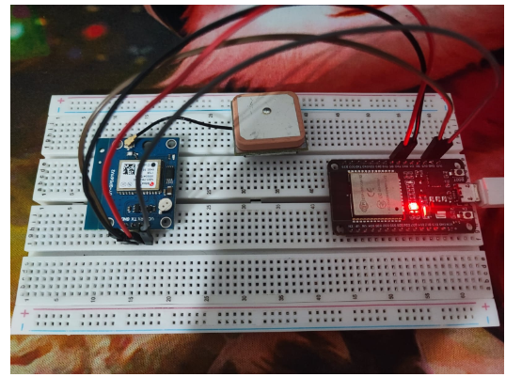7. Reading location using GPS module:

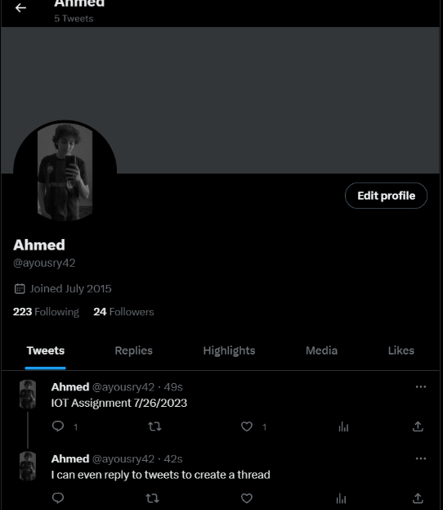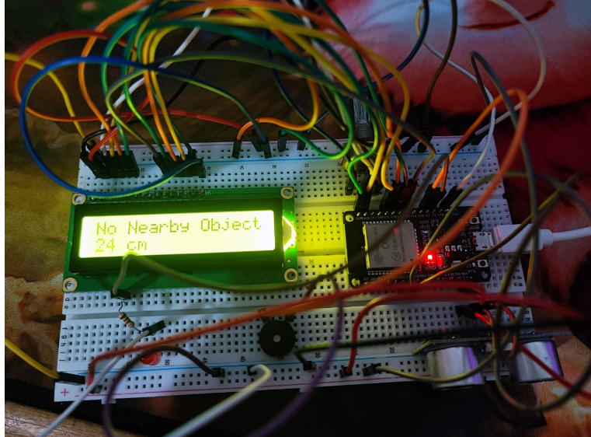8. Measure the distance using ultrasonic sensors, then verify against a threshold value, display the result on an LCD screen, and finally, post a tweet on Twitter:

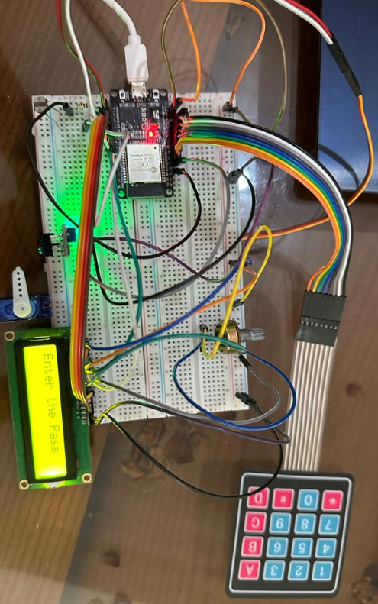9. Enter a password using the keypad, and if it's correct, display it on the LCD. In the correct case, the servo motor will rotate 180 degrees:

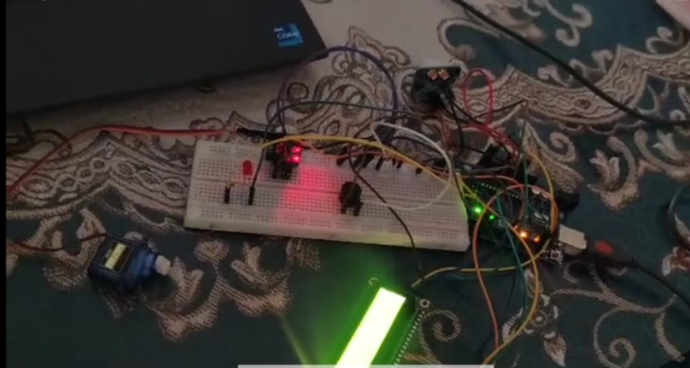10. Using gas sensor and flame sensor to dectec gas or flame and in correct case

the servo motor will rotate 180 degrees:

**5.3 Week 4&5:**

During week 4&5, we covered the following topics:

1. Capex and Its Problems:

We explored the concept of capital expenditure and delved into the associated challenges and drawbacks. This financial term refers to investments made in

assets with the goal of generating future returns.

2. Meaning of Cloud and Cloud Computing:

We discussed the meaning of Cloud/Cloud computing which entails the delivery of computing services such as storage, databases, servers, networking, software, analytics, and intelligence over the internet. We delved into its fundamental concepts, emphasizing how this model offers scalability, flexibility, and cost-effectiveness.

3. Cloud Deployment Models:

Cloud deployment models were explored, encompassing public, private, and hybrid cloud configurations. We examined how organizations choose between these models based on factors like data security, control, and scalability requirements.

4. Benefits of Cloud:

We discussed how the cloud empowers businesses to streamline operations and innovate faster by reducing the need for physical infrastructure and maintenance.

5. Disadvantages of Cloud:

We discussed concerns related to data security, dependency on internet connectivity, and potential vendor lock-in. By examining both the benefits and drawbacks, we developed a well-rounded understanding of the cloud's implications.

6. Private, Public, and Hybrid Cloud:

We examined the distinctions between private, public, and hybrid cloud deployments. Through a detailed discussion, we understood how private clouds provide dedicated infrastructure, public clouds offer shared resources, and hybrid clouds blend the best of both worlds to cater to diverse organizational needs.

7. Difference between IaaS, BaaS, PaaS, and SaaS:

We engaged in a comparative analysis of IaaS, BaaS, PaaS, and SaaS, emphasizing how they offer varying levels of abstraction and management. By understanding the distinctions, we could appreciate how these models cater to different requirements.

8. Definition of High Availability, Scaling, Scalability, and Resources:

We explored how high availability ensures systems remain operational, while scalability refers to the capacity to accommodate growth.

9. Physical Infrastructure, Regions, Availability Zones, and Region Pairs:

We discussed the layout of these zones and regions, explaining how they contribute to redundancy, fault tolerance, and data integrity.

10. Serverless Computing:

We examined how serverless platforms offer automated scaling and resource allocation, leading to increased efficiency.

11. Microsoft Azure Basics:

We introduced Microsoft Azure, a cloud computing platform, and discussed its fundamental features.

12. Virtual Machines on Azure Tutorial:

This tutorial guide covered how to create and manage virtual machines within the Azure environment.

13. Basic Azure Functions:

We discussed the concept of Azure Functions, which allow users to run code without managing infrastructure.

.

14. Introduction to Networks:

We explored the basics of network communication, discussing how devices connect and exchange data.

15. Client-Server Architecture and Paradigm:

We discussed the communication process between clients and servers, as well as the benefits it brings to distributing tasks.

16. Protocol Layers and Reference Models:

We discussed how the OSI and TCP/IP reference models provide a framework for understanding networking protocols.

17. Communication Model and Layering:

We delved deeper into the communication model, emphasizing the role of layers.

18. Understanding Protocols:

We examined how protocols facilitate smooth communication in networking.

19. Services, Layering, and Encapsulation:

We explored how services, layering, and encapsulation enhance communication. We ensure efficient and organized data exchange.

20. Backend Design Patterns:

We delved into various backend design patterns, such as the request-response model, push mechanism, short polling, and publish-subscribe model.

21. HTTP Protocol, HTTPS Protocol, and Its Different Versions:

The HTTP protocol and its versions were introduced, showcasing how it enables communication between web clients and servers.

We examined how it encrypts data transmission to safeguard sensitive information in HTTPS.

22. Websocket Protocol:

We explored how it enables bidirectional communication between clients and servers.

23. Introduction to Firebase:

Firebase, a comprehensive platform for building web and mobile applications, was introduced. We discussed its features and how it simplifies development tasks especially in ESP32.

24. Firebase Services:

We delved into various services offered by Firebase, including real-time databases, authentication, and hosting. These services streamline app development and enhance user experiences.

25. Identification, Authentication, and Authorization:

We explored how these elements contribute to secure user interactions.

26. ID Token vs Access Token:

We examined the distinctions between ID tokens and access tokens, two tokens used for different purposes in authentication.

27. JWT Token and Digital Signature:

The concept of JWT tokens and digital signatures was explored, emphasizing their role in verifying the authenticity of data and ensuring secure communication.

28. SQL vs NoSQL Databases:

We were highlighting how each type serves specific data storage and retrieval needs.

29. Real-time Database in Firebase:

We discussed how it enables synchronized, real-time updates across connected clients.

30. We practiced all these topics in both lectures and assignments, and here are

some photos of the assignments we worked on:

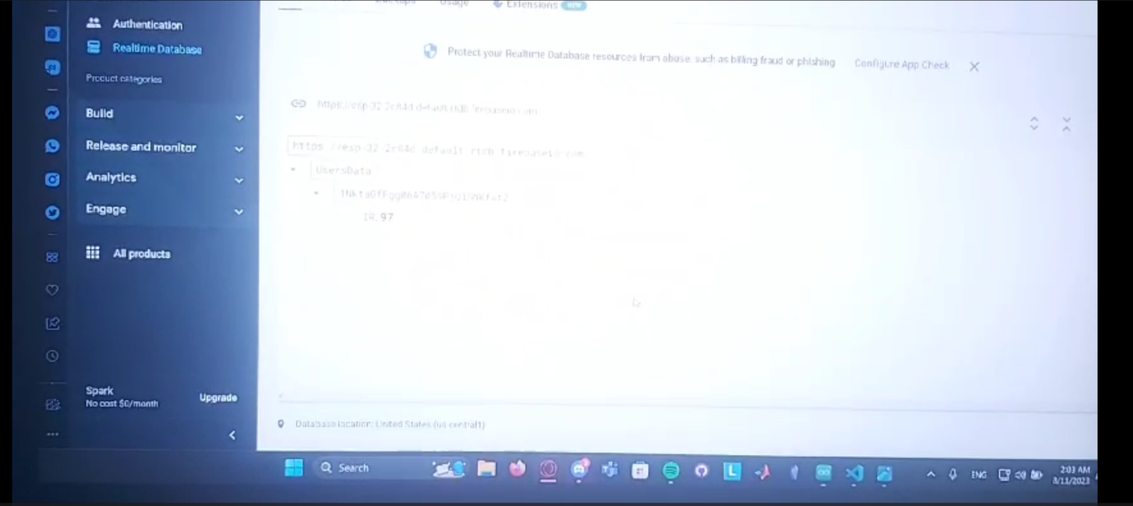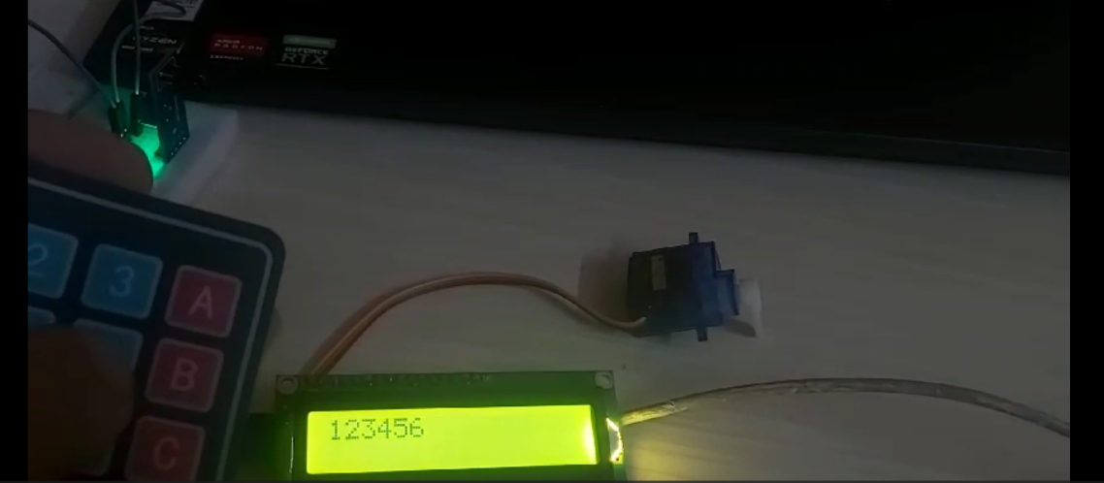1) Enter a password (mail-password authentication) and display it on the LCD. If the password is correct, the ESP32 will read the distance from the IR sensor and then store the value in the Realtime Database:

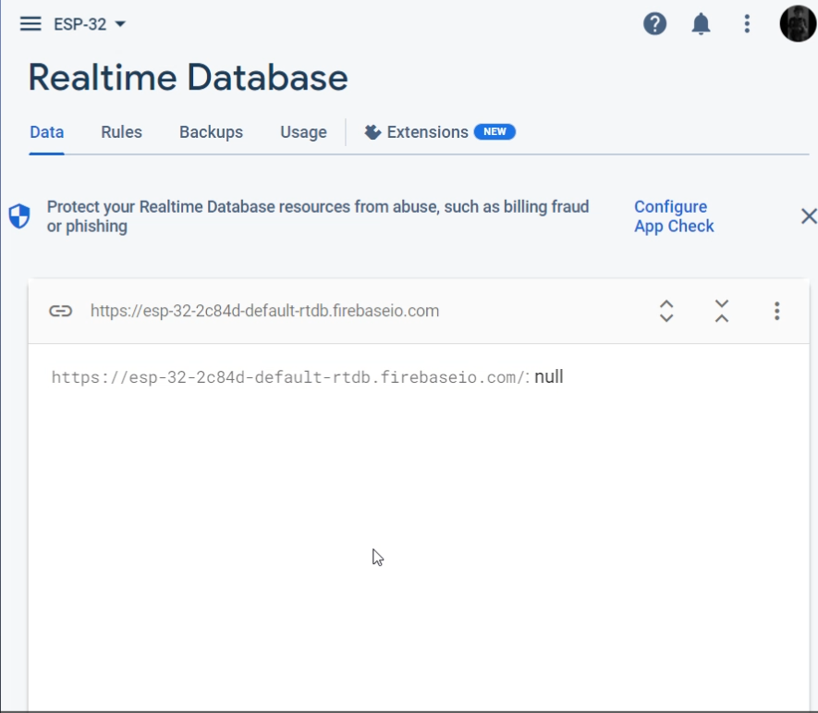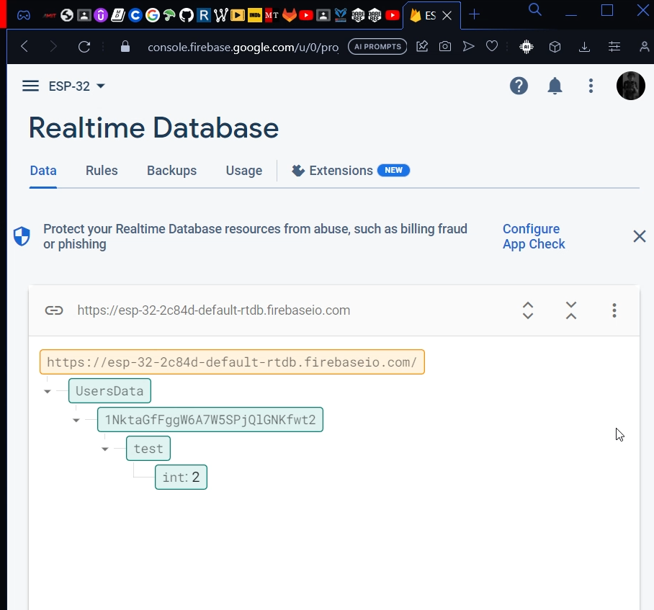2) Read the distance value then delete it :

**5.4 Week 6:**

During week 6, we covered the following topics:

1. Introduction to Dart and Development Environment:

We delved into the fundamentals of Dart programming language, covering basic syntax, data types, and functions. Additionally, we familiarized ourselves with development environments such as Android Studio and Visual Studio Code, essential for Flutter app development.

2. Flutter: A Versatile Open Source SDK:

We explored the capabilities of Flutter, an open source SDK by Google.

3. UI and UX Design Fundamentals:

We discussed the definitions, differences, and the tools available for designing user friendly and visually appealing interfaces. Software like Figma were introduced.

4. Flutter Architecture:

We differentiated between stateful and stateless widgets, understanding when and how to use them effectively.

5. Layout Management in Flutter:

We extensively discussed and practiced layout management techniques in Flutter. Through practical examples, we implemented layouts using widgets like Row, Column, and Scaffold.

6. Child and Children Widgets:

We dove into their distinctions, use cases, and their impact on widget composition within Flutter applications.

7. Dart Language Deep Dive:

We delved into Dart's features, covering variables, data types, functions, lists, maps, and classes.

8. Implementing Lists with and without Navigation:

We tackled practice problems involving the implementation of lists both with and without navigation, reinforcing our skills in handling user interfaces and navigation flows.

9. Introduction to Firebase and Integration:

We explored its functionalities and services, discovering how they can be leveraged within Flutter apps.

10. Firebase Integration: Two Approaches:

We learned two distinct methods to integrate Firebase with Flutter projects. This knowledge enabled us to seamlessly incorporate real-time database features into our applications.

11. Real-time Sensor Data Display:

We embarked on a practical endeavor to retrieve real-time sensor readings from Firebase and display them within a Flutter app. This hands-on project showcased the practical application of our learning.

**6. Training project**

As for me I handled electronic and code part along with Fares Hazem.

Smart Home:

Our team has ingeniously crafted a smart home system that offers both remote and physical control. Through an intuitive mobile app interface, users gain authority over various aspects of their home environment.

The functionality extends to the manipulation of gates and windows with a simple tap on the app.

Upon gate entry, users can seamlessly open and close windows using the app's interface.

A touch pad serves as an innovative doorbell, embracing modern technology to announce visitors.

For enhanced security, a keypad is integrated, requiring a physical entry of a password to grant gate access. This password is thoughtfully displayed on an LCD screen, and its correctness is verified before permitting entry.

The convenience factor is heightened with the ability to control fans using the mobile app.

Moreover, an IR sensor is strategically employed to distances, facilitating the automatic opening of internal doors.

Servo motors play a role in the system's operation, with a 360-degree servo motor overseeing gate and window movements, while an internal door is managed by a 180-degree servo motor.

Rain sensor is also used in smart home to detect the rain drops to close the window.

Safety is a paramount concern, and our system addresses it comprehensively.

Smoke and flame sensors are utilized to promptly detect any signs of smoke or flames.

In such a situation, not only are gates, doors, and windows triggered to open, but a buzzer alert is also activated, ensuring the safety of the occupants.

Lamp control is also integrated, allowing users to illuminate their space remotely via the mobile app.

The orchestration of all mobile app commands and ESP32 commands, whether for reading or writing, is executed through a Realtime database, all centrally managed by the ESP32 module.

Smart home photos:

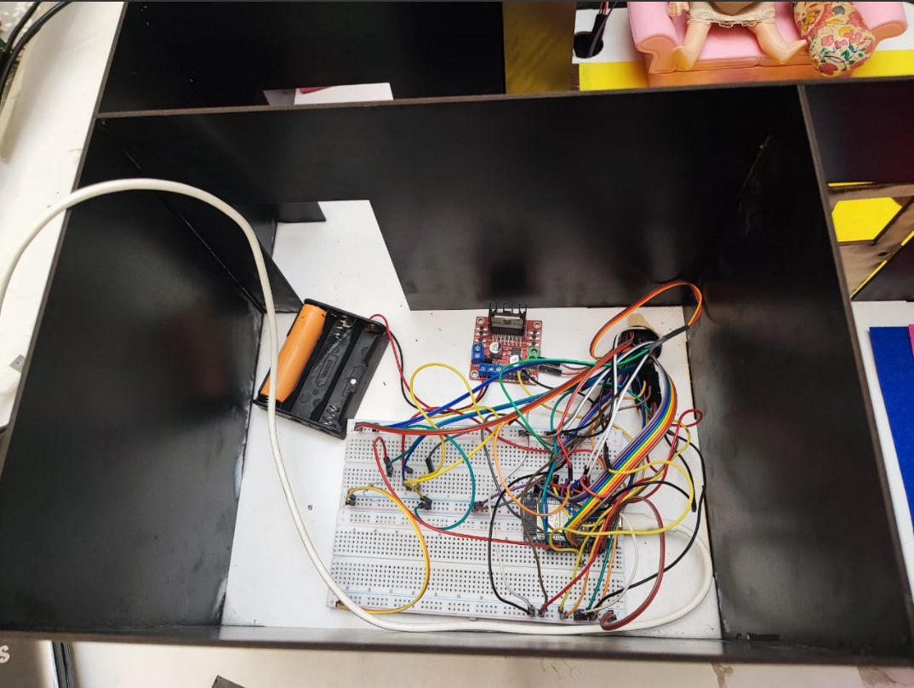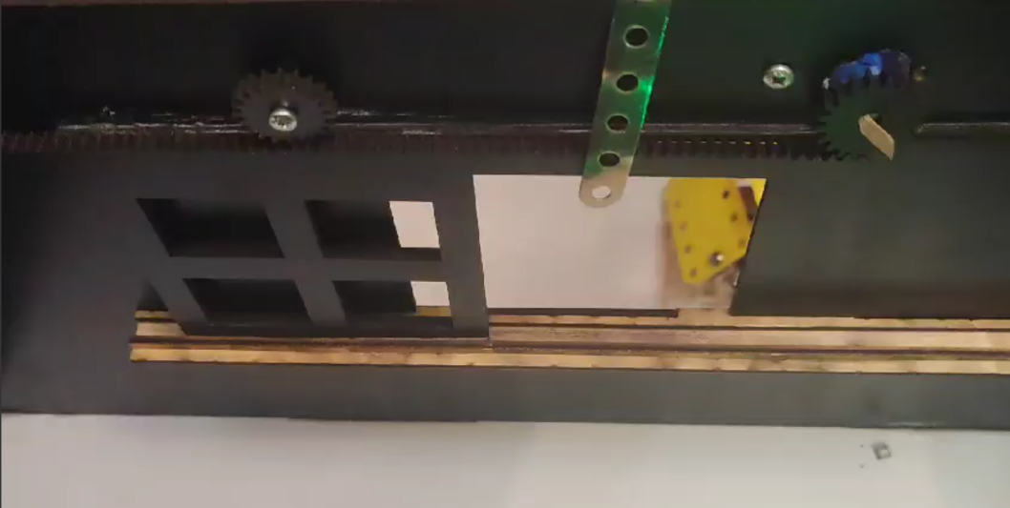

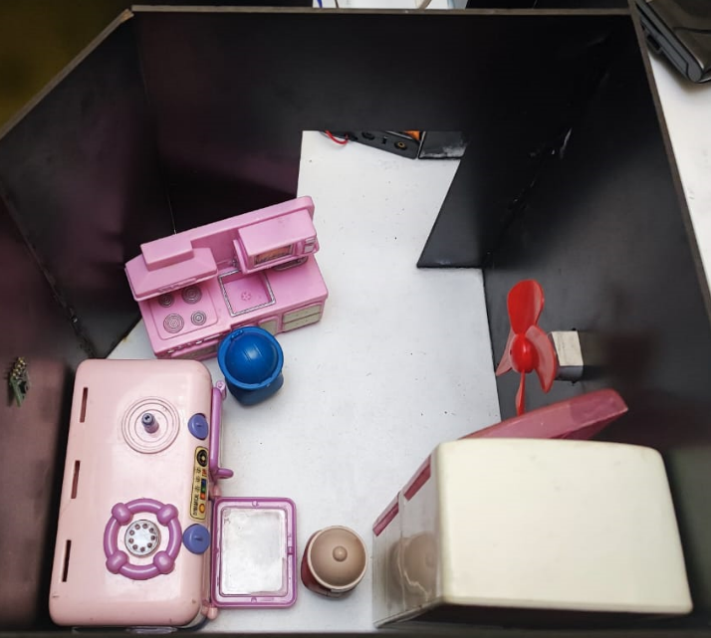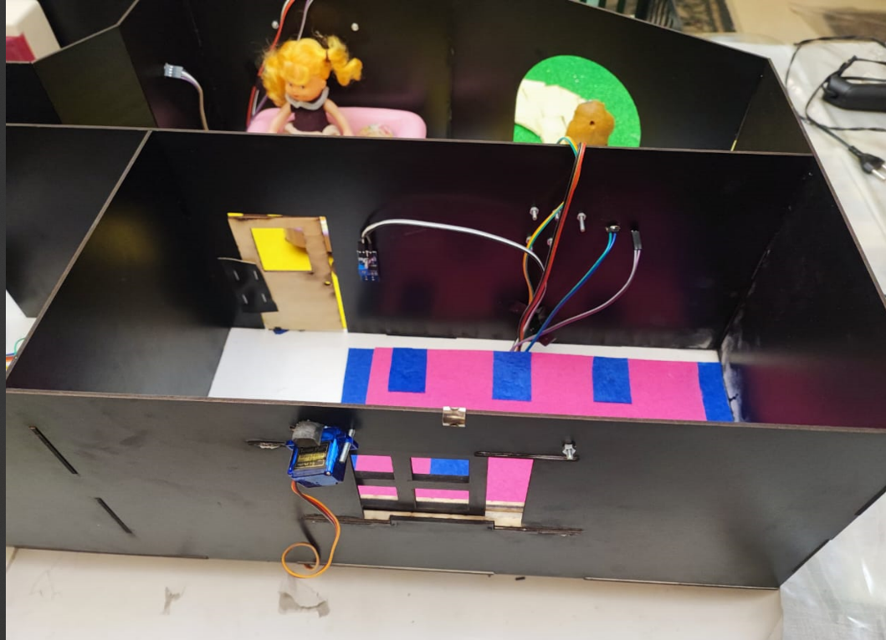

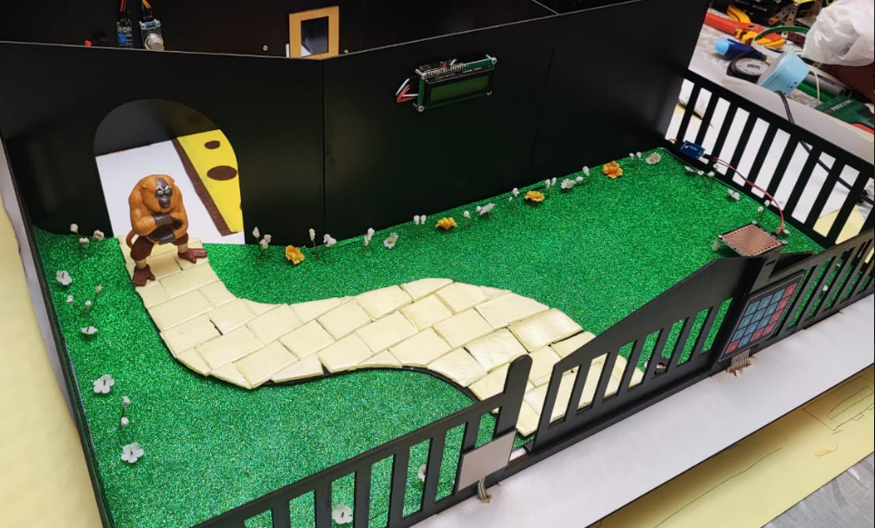

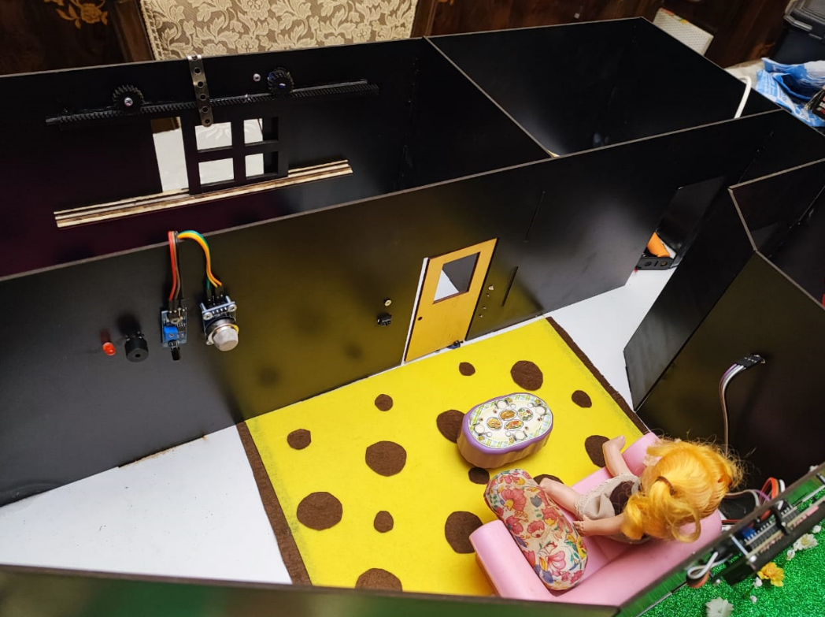

Robot Car:

Our team's ingenuity extends to the creation of a robot car equipped with cutting-edge features. Guided by a 3-channel line tracker, the robot car navigates autonomously by tracing lines, with users empowered to select its parking destination. In order to ensure safe navigation, an ultrasonic sensor is employed to calculate distances, prompting the car to halt in the presence of obstacles.

The robot car's mechanical components include DC motors, wheels, an H-bridge circuit, and a power supply comprising three battery cells. The brains of the operation are powered by an ESP32 module, which governs communication and decision-making processes.

Much like the smart home, the robot car is controlled through a mobile app interface and an ESP32-based real-time database, ensuring that user commands and data updates are executed seamlessly.

Robot code is explained as follow:

The code starts by defining the pin numbers for various motor control inputs and enable pins. These pins are used to control the direction and speed of the connected motors.

The code defines several custom functions for controlling the motors' movements:

motorBackward(): Sets the motor control pins to move both motors

backward.motorForward(): Sets the motor control pins to move both motors

forward.motorTurn1(): Turns one motor while keeping the other still to achieve a turning

motion.motorTurn2(): Turns the other motor while keeping the first one still to achieve a different turning

motion.motorStop(): Stops both motors by setting all control pins to LOW.

At the outset, the code imports essential libraries, including those for Firebase integration and secure Wi-Fi connectivity. It establishes a connection with the Firebase database by specifying the host link and authorization credentials. Additionally, it defines strings for Firebase paths related to parking slot occupancy data and the preferred parking position for the robot.

The `slotOccupied` array, comprised of four Boolean values, meticulously monitors the occupancy status of parking slots. The `park_pos` variable stores the user's chosen parking position for the robot, while `lafa` is a variable employed for specific maneuvers.

The `read()` function is dedicated to extracting relevant data from the Firebase database. It retrieves the desired parking position and examines parking slot occupancy via Firebase Boolean values.

In the primary loop of the program, the system enters the decision-making phase, during which the robot's actions are determined. The mobile app serves as the controller, indicating the robot's designated actions based on user preferences. Inputs like `leftSensor`, `centerSensor`, and `rightSensor` are employed to interpret signals from line-following sensors, while the ultrasonic sensor's `trigPin` and `echoPin` inputs enable precise distance measurements.

Within the loop, conditional statements evaluate the robot's behavior by considering the parking slot chosen through the mobile app and the readings from the line-following sensors. These conditions steer the robot's movement strategies, including moving forward, executing turns, and coming to a halt. The parking procedures are activated by invoking functions such as `park1()`, `park2()`, `park3()`, and `park4()`, each tailored to a specific parking slot and its corresponding sensor conditions.

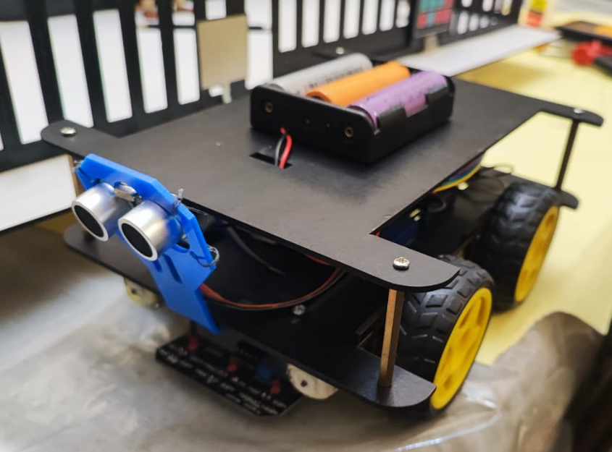Robot car pictures:

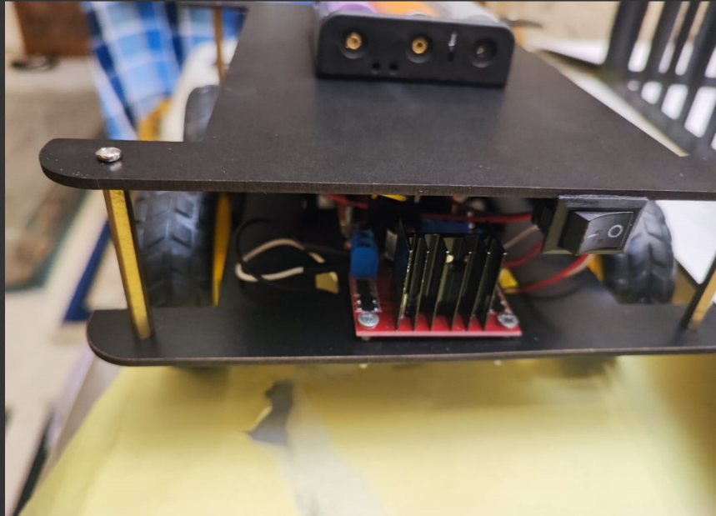

Smart Garage:

Our innovative prowess extends to the realm of smart garages, where our team has crafted a system that redefines parking management. Four IR sensors are meticulously positioned to detect parking occupancy, with corresponding LEDs indicating whether a parking space is occupied or not. For a comprehensive overview, an OLED screen displays the occupancy status of all four parking spots.

The user experience and interface are carefully considered, with the app developed using Flutter, ensuring both functionality and aesthetic appeal. The backend is powered by Google Firebase, harnessing its real-time database capabilities to facilitate instantaneous updates of parking status.

Garage code:

The code begins with the inclusion of essential libraries: Wire.h for I2C communication and Adafruit_GFX.h along with Adafruit_SSD1306.h for interacting with an SSD1306 OLED display. The display dimensions are defined, and an Adafruit_SSD1306 object named display is created to handle the display's functionalities.

Pin assignments are established for IR sensors, LEDs, and a buzzer.

The variable numSlots is computed by dividing the size of irPins[] array by the size of an individual element. Additionally, an array named slotOccupied is initialized to keep track of the occupancy status of each parking slot.

The setup() function initializes serial communication at a baud rate of 9600. The OLED display is initiated with specified parameters, and an introductory message is printed. Each IR sensor pin is set as input, and each LED pin is set as output. The buzzer pin is also configured as an output.

The analog value from the IR sensor is read using analogRead() and stored in the variable sensorValue. Based on a threshold value of 3000, the variable occupied is determined, indicating whether a slot is occupied or not.

If a slot becomes occupied and was previously unoccupied (slotOccupied[i] is false), the corresponding LED is turned off and the buzzer is briefly activated. The slotOccupied array is updated to reflect the new status. Conversely, if the slot is unoccupied, the LED is turned on, and slotOccupied[i] is set to false.

The OLED display is updated to show the slot number and its occupancy status (either "Occupied" or "Empty"). Corresponding information is also printed to the Serial Monitor for monitoring and debugging.

Wire.h: This library is utilized for I2C communication, which is often used for communication between microcontrollers and various sensors or devices.

Adafruit_GFX.h and Adafruit_SSD1306.h: These libraries enable the interaction with the OLED display, allowing for graphics rendering and text display.

FirebaseESP32.h and WiFiClientSecure.h: These libraries are vital for integrating the system with the Firebase Realtime Database. They facilitate secure communication with the cloud-based database service.

Firebase Configuration:

Firebase is a cloud-based platform that offers a real-time database solution. The code configures the Firebase database connection using the provided `FIREBASE_HOST` and `FIREBASE_AUTH` parameters. These parameters serve as identifiers that allow the Arduino to establish communication with the Firebase server.

Wi-Fi Setup:

To establish network connectivity, the code connects to a specified Wi-Fi network. The Wi-Fi network's credentials, including the network name (`wifi_name`) and password (`password`), are used for authentication and connection establishment.

- Interaction with Firebase: If a change in occupancy status is detected, the system interacts with the Firebase Realtime Database. The `upload()` function is called to send the updated slot occupancy information to the Firebase server.

Garage image:

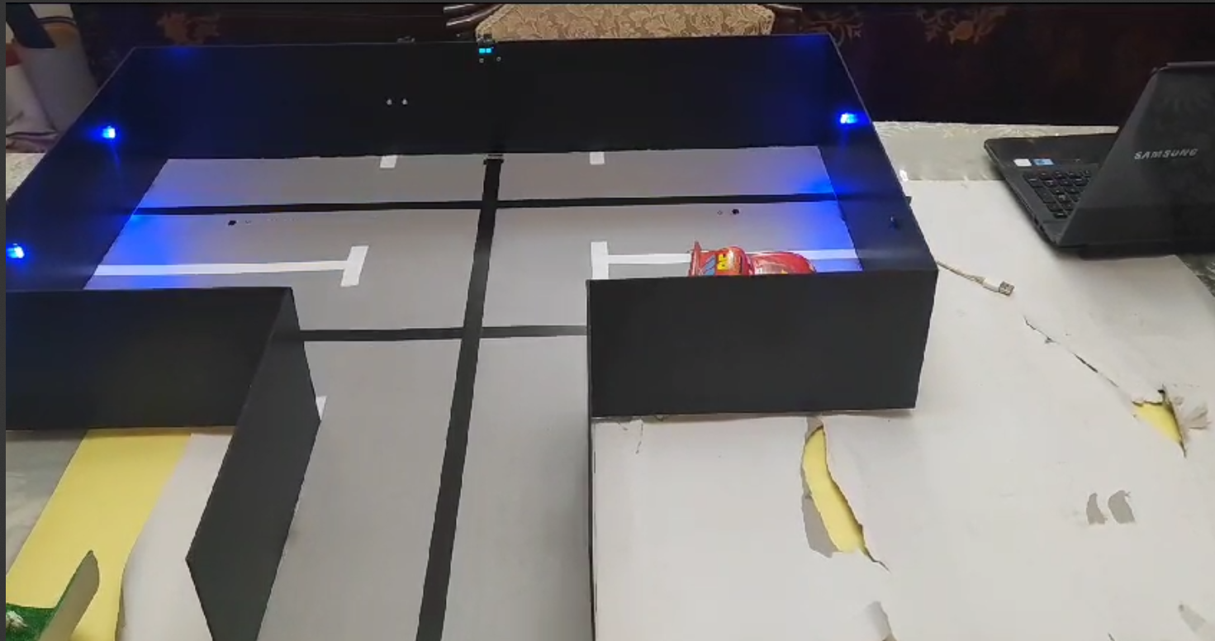

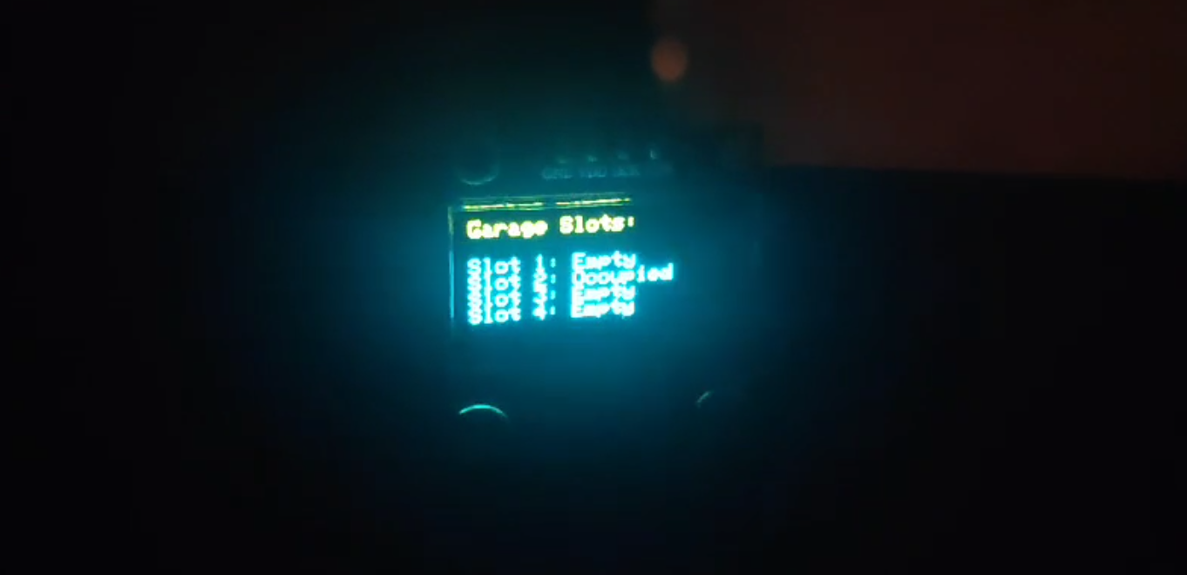

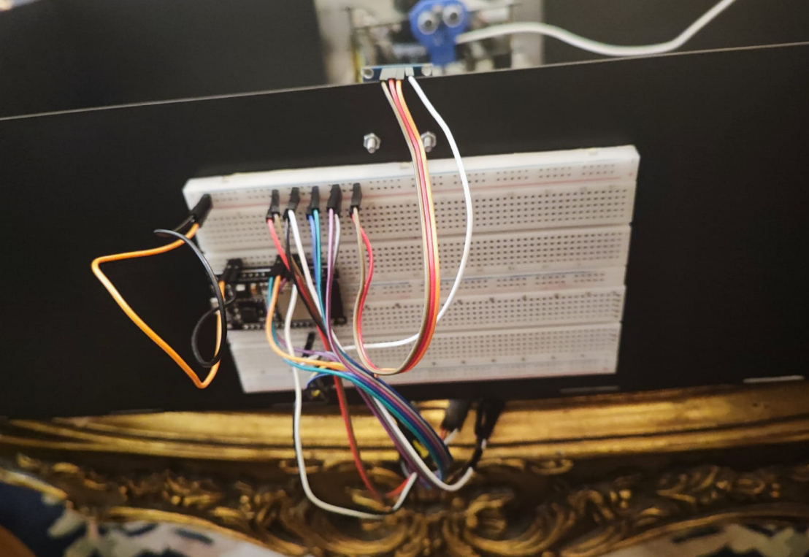

When it comes to the mobile application aspect of our project, our attention to detail and user-centric approach shine through in every pixel of the design. We've invested significant effort in crafting an intuitive and visually appealing UX that seamlessly interacts with the intricate functionalities of our smart home, robot car, and smart garage systems.

Our UI design is not just about aesthetics; it's about creating a bridge between the advanced technologies at play and the end users who interact with them.

The user experience design process has been guided by a commitment to simplicity and functionality. Each screen, icon, and element has been meticulously considered to ensure ease of navigation, clear communication of features, and an overall cohesive feel. We've create a design that feels familiar and natural, allowing users to quickly grasp the capabilities and controls our systems offer.

From the arrangement of buttons for controlling windows, gates, and fans in the smart home, to the visual representation of parking availability in the smart garage, and the intuitive controls for directing the robot car, every aspect of the app design is intended to enhance user engagement and understanding.

I would like to express my sincere gratitude to Omar Gamal and Ahmed Dawood for their invaluable contributions and unwavering assistance during the development of the Flutter app for our IoT project. Their dedication, expertise, and collaborative spirit were instrumental in bringing the app to fruition. Their insightful inputs and diligent efforts have greatly enriched the functionality and user experience of our project.

For the backend part:

Smart Garage Firebase Integration:

Within the framework of the smart garage system, Firebase Integration assumes a pivotal role in enabling real-time monitoring and control of parking spaces within the garage.

Firebase functions as a cloud-based platform for storing and retrieving data, fostering seamless communication between the garage's infrastructure and external devices. This interaction through Firebase encompasses a spectrum of functions, including parking preferences, occupancy status updates, and instantaneous notifications.

Consequently, a holistic understanding of the garage's operations is effortlessly delivered.

The code implementation initiates a connection with Firebase through authenticated credentials, thereby facilitating the bidirectional transfer of data to and from Firebase's real-time database. Upon a vehicle's entry into the garage, the system retrieves the user's parking preferences stored in Firebase. This extracted information guides the automated parking logic, streamlining the parking process. Subsequent changes in parking slot occupancy, as vehicles enter or exit, are meticulously tracked and reflected in Firebase's database. Users, irrespective of their location, gain the ability to remotely monitor available parking spaces due to this dynamic information exchange. The symmetrical flow of data guarantees the synchronization of the garage's status across all devices and users.

Smart Home Firebase Integration:

Within the realm of home security and automation, Firebase Integration serves as the backbone for creating a connected ecosystem that enables users to monitor and control various aspects of their home remotely. By interfacing with Firebase's real-time database, the code establishes a seamless channel for data exchange between the IoT devices and the cloud-based platform.

The system leverages Firebase to receive and store data related to security status, environmental conditions, and user interactions. For instance, when a user enters the correct passcode on the security keypad, Firebase is updated with the authorized access status. This real-time communication allows users to remotely verify and control access to their home.

In the case of environmental monitoring, the AHT10/AHT20 temperature and humidity sensor data is sent to Firebase for analysis. Users can access this data remotely to ensure that their home environment remains within desired parameters. Moreover, the rain detection sensor's status is also communicated to Firebase, enabling users to ascertain whether it's raining at their location.

Firebase Integration plays a pivotal role in enhancing user control by allowing users to remotely operate the fan and receive notifications about critical events. For instance, users can toggle the fan on or off through Firebase, and if a fire or smoke detection event occurs, Firebase is updated with the relevant information, triggering notifications that provide timely alerts to users.

Car-Robot Firebase Integration:

The initial steps of the project involve importing essential libraries such as FirebaseESP32.h and WiFiClientSecure.h. These libraries provide the necessary tools to establish a secure connection between the ESP32 device and Firebase servers over a WiFi network.To configure Firebase for the project, specific project-related details are provided.

This includes the definition of FIREBASE_HOST, which specifies the URL of the Firebase Realtime Database being used, and FIREBASE_AUTH, which is an authentication token or key ensuring secure communication between the ESP32 and Firebase services.The setup process starts with establishing a WiFi connection using the provided network credentials (wifi_name and password).

This connection is essential as it enables the ESP32 device to effectively communicate with Firebase's cloud services.The core functionality of Firebase integration revolves around the data reading mechanism. Firebase's Realtime Database capabilities are leveraged to retrieve critical information about parking positions and their occupancy status.

Utilizing functions like Firebase.getInt() and Firebase.getBool(), the project fetches data stored in predefined paths within the database.This integration empowers the ESP32-based parking management system to make informed decisions regarding parking positions and occupancy. By continuously accessing and updating data on the Firebase cloud, the system gains real-time insights into available parking spots and their utilization. This enables the ESP32 to efficiently navigate the parking area and execute parking maneuvers.In conclusion, the integration of Firebase into this IoT project significantly elevates its capabilities.

By incorporating Firebase's Realtime Database, the project achieves seamless data exchange, real-time monitoring, and effective decision-making, all of which are fundamental for an efficient parking management system. This integration exemplifies the practical utilization of cloud-based services to enhance the performance and intelligence of IoT devices.

I would like to extend my sincere gratitude to Ahmed Ehab for his invaluable contributions and unwavering assistance in the Firebase Integration segment of our IoT project report. His expertise and dedication have been instrumental in ensuring the seamless integration of Firebase, which has significantly enhanced the real-time monitoring and control capabilities of our smart garage system.

Ahmed's insights and efforts have played a pivotal role in the success of this project, and I am truly appreciative of his collaboration.

**7. Challenges and Solutions**

Challenges and Solutions for Smart Home:

1. Integration Complexity:

Challenge: Integrating a wide range of devices, sensors, and control mechanisms within the smart home ecosystem posed challenges in terms of compatibility and communication.

Solution: We adopted a modular approach, ensuring that each component's specifications were compatible with the chosen communication protocols. This facilitated seamless interactions between devices. Extensive testing and debugging were carried out to ensure smooth integration.

2. User Experience Consistency:

Challenge: Maintaining a consistent and intuitive user experience across both the physical controls and the mobile app was a challenge due to the differing interaction methods.

Solution: We conducted thorough user testing to gather feedback and refine the user interfaces. This iterative process led to a cohesive user experience that seamlessly transitioned between physical and app-based controls.

3. Data Security and Privacy:

Challenge: Ensuring the security of user data and preventing unauthorized access to the smart home system required robust encryption and authentication mechanisms.

Solution: We implemented strong encryption protocols and two-factor authentication for the mobile app.

Challenges and Solutions for Smart Garage:

1. Sensor Calibration and Reliability:

Challenge: Calibrating IR sensors to accurately detect parking occupancy, regardless of environmental conditions, presented a challenge.

Solution: Rigorous testing and calibration processes were employed to fine-tune sensor thresholds. Adaptive algorithms were developed to account for variations in lighting and reflectivity, ensuring reliable detection.

2. Real-Time Data Synchronization:

Challenge: Ensuring real-time updates on parking space occupancy across multiple devices, including the mobile app and the OLED display, required minimizing latency.

Solution: We utilized cloud-based solutions like Google Firebase to manage and synchronize data in real-time.

3. LED Visibility and Feedback:

Challenge: Designing LED indicators that were visible under various lighting conditions and from different angles proved challenging.

Solution: LED placement was strategically chosen to maximize visibility, and LEDs with appropriate brightness levels were selected. Prototyping and user testing confirmed the effectiveness of the LED feedback system.

Challenges and Solutions for Robot Car:

1. Line Tracking Precision:

Challenge: Designing an accurate line tracking system that reliably guides the robot car along designated paths presented challenges, especially on different surfaces and lighting conditions.

Solution: The line tracker's sensor parameters were meticulously calibrated, and PID control algorithms were implemented to ensure consistent and accurate tracking. Testing was conducted across diverse environments to validate performance.

2. Obstacle Detection and Avoidance:

Challenge: Implementing an effective obstacle detection system using ultrasonic sensors required addressing complexities related to sensor accuracy and the car's response speed.

Solution: Sensitivity adjustments and threshold tuning were performed to enhance the accuracy of obstacle detection. The car's response algorithms were optimized to ensure timely and efficient obstacle avoidance maneuvers.

3. Mobile App Interface Complexity:

Challenge: Designing a mobile app interface that allowed users to control the robot car's movement and choose parking spots required managing the complexity of these interactions.

Solution: The app's interface was designed with simplicity in mind, utilizing intuitive icons and clear controls. User testing and feedback were instrumental in refining the app's design to ensure user-friendliness.

**8. Learning Outcomes from IoT Training:**

1. Solid Grasp of IoT Concepts:

The training has afforded me a robust understanding of the fundamental principles that underpin the Internet of Things (IoT). This knowledge has allowed me to comprehend the intricate interplay between connected devices and how they collectively contribute to creating intelligent and interconnected environments.

2. Seamless Fusion of Hardware and Software:

Through hands-on engagement with tasks and assignments involving an array of hardware components, including sensors, actuators, and microcontrollers such as ESP32, I've honed my proficiency in harmoniously integrating diverse hardware elements into cohesive and functional systems. This integration was complemented by my ability to interface these components with software solutions.

3. Mastery of ESP32 Microcontroller:

The extensive interaction with the ESP32 microcontroller has resulted in a heightened level of competence in programming and configuring this versatile platform. This newfound mastery has enabled me to harness the full potential of the ESP32 for diverse IoT applications, particularly in real-time data communication and remote control scenarios.

4. Crafting Cross-Platform Apps with Flutter:

The training's emphasis on developing mobile applications using the Flutter framework has expanded my skill set considerably. I am now adept at conceptualizing and creating cross-platform applications characterized by engaging user interfaces. These applications seamlessly interact with IoT systems, enhancing user experience.

5. Leveraging Cloud Power through Firebase:

My foray into utilizing Google Firebase for backend development has provided me with a practical understanding of setting up databases and harnessing cloud services for efficient data exchange. This proficiency has empowered me to establish real-time data synchronization mechanisms that are integral to successful IoT solutions.

6. Team Collaboration and Project Management:

Collaborating effectively within my team, particularly during the ambitious final project involving the creation of smart home, smart garage, and robot car systems, has enriched my project management and collaborative skills. This experience has fostered my ability to coordinate tasks, maintain open lines of communication, and ensure the harmonious execution of complex projects.

7. Prioritizing IoT Security and Privacy:

The training's emphasis on IoT security has equipped me with a comprehensive understanding of encryption, authentication, and the implementation of secure data exchange protocols.

8. Mastering Troubleshooting and Innovative Problem-Solving:

My engagement with tasks that demanded both hardware and software debugging has honed my analytical and troubleshooting prowess. These experiences have further elevated my ability to identify challenges, devise effective solutions, and ensure the seamless operation of intricate systems.

9. Application of Theoretical Concepts to Real-World Solutions:

The training's dynamic blend of theoretical knowledge and hands-on application has empowered me to bridge the gap between classroom theory and real-world implementation.

**9.Conclution**

In conclusion, the IoT training program has been an illuminating voyage that has not only deepened my understanding of the intricate world of connected technologies but also equipped me with a toolkit of invaluable skills. Through a diverse range of assignments, hands-on tasks, and culminating projects, I have traversed the realms of microcontroller programming, mobile app development, cloud integration, sensor utilization, and collaborative project management.

This journey has highlighted the remarkable potential of IoT to revolutionize industries and lifestyles, fostering innovation and efficiency. By immersing myself in the development of a smart home, smart garage, and robot car, I have gained insights into the intricate interplay between hardware and software, while also sharpening my troubleshooting abilities.

Beyond the technical facets, the training has nurtured my ability to think creatively, adapt to evolving technologies, and work seamlessly within a team. It has shown me the art of translating theoretical concepts into tangible solutions that cater to real-world challenges.

As I look towards the horizon, the knowledge gained from this training will undoubtedly serve as a cornerstone for my future endeavors. Whether it's creating smart solutions, developing intuitive user interfaces, or contributing to the ever-growing IoT ecosystem, I am now equipped to make meaningful contributions.

I would like to express my sincere appreciation to my mentors, Eng Hatem, Eng Mohamed, and Eng Menna, for their unwavering dedication, expertise, and constant support throughout this IoT training journey.

Eng Hatem's guidance in C++ and ESP32 coding, Eng Mohamed's insights into Firebase, and Eng Menna's expertise in Flutter have been instrumental in expanding my skills and knowledge in these crucial areas. Their patience and excellence in teaching have truly set the foundation for my growth.

Furthermore, I wish to extend my gratitude to my exceptional team members, Omar Gamal, Ahmed Dawood, Ahmed Ehab, and Fares Hazem. Their collective effort, seamless collaboration, and problem-solving skills have been a cornerstone of our success. Together, we navigated challenges, shared insights, and achieved remarkable outcomes, showcasing the power of teamwork in our pursuit of excellence.

As I reflect on this journey, I am immensely thankful for the camaraderie, guidance, and shared passion that have defined this IoT training experience. Each individual's contribution has contributed to a tapestry of knowledge and achievement that will continue to inspire me as I move forward.